CREATING REPORTS

Creating reports is done under “Analysis” Button.

Creating reports can be done in any module such as test, requirements, management, development

Whatever the report kind first open that module then click on analysis, available reports will be listed.

In this example we will see “Requirement Reports”

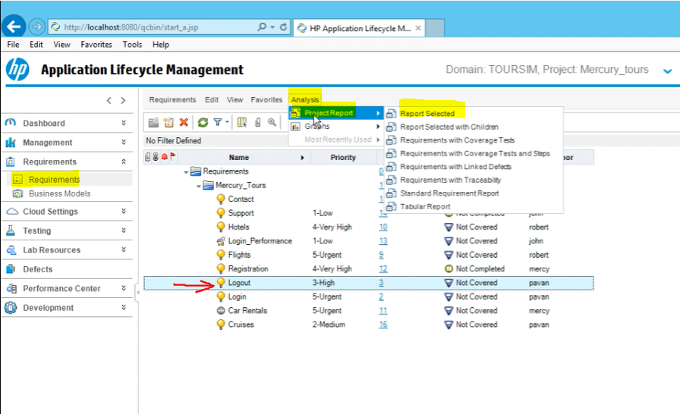

Since we are on the Logout Requirement, Report will be only for Logout requirement.

Opening window is just a Preview so it may not show the whole report

In order to see the whole report, click on “Generate” button and select the format then it will show the full report

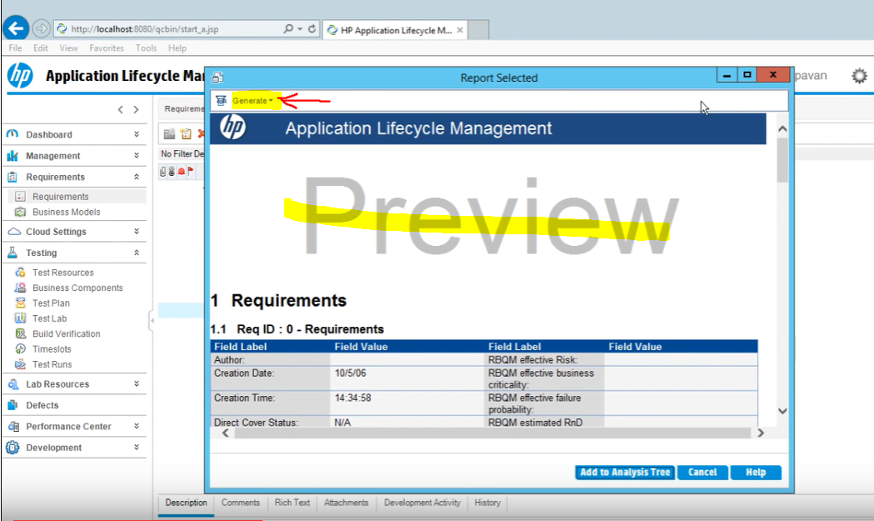

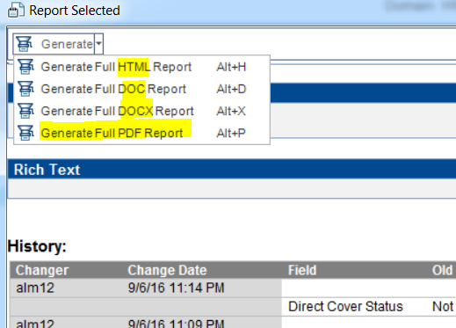

Full Report will look like this.

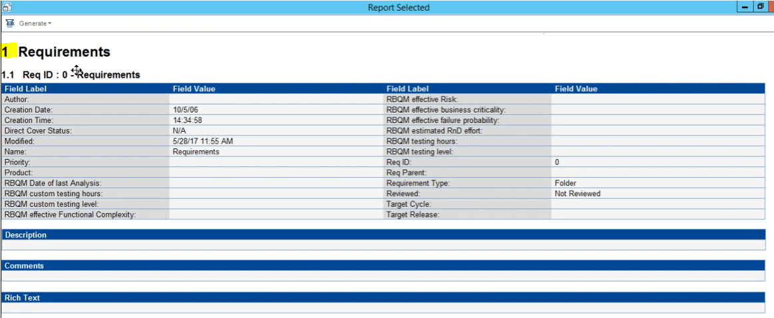

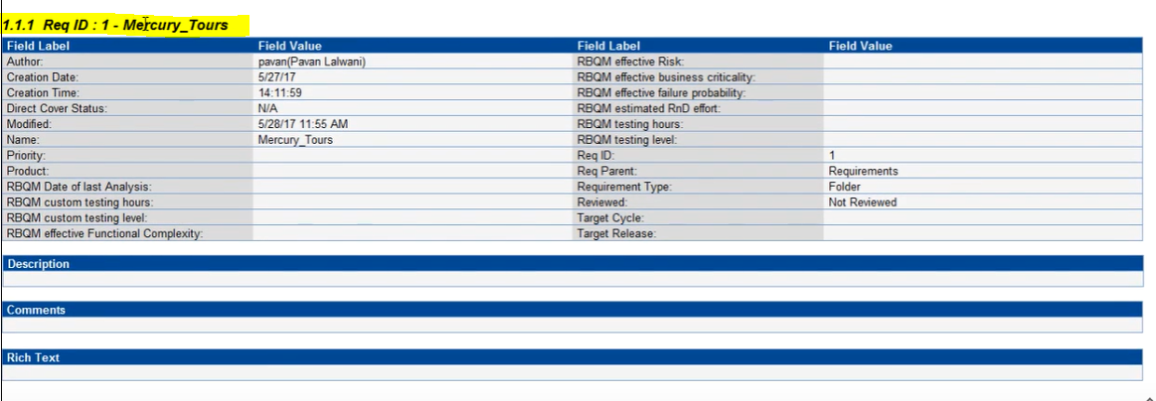

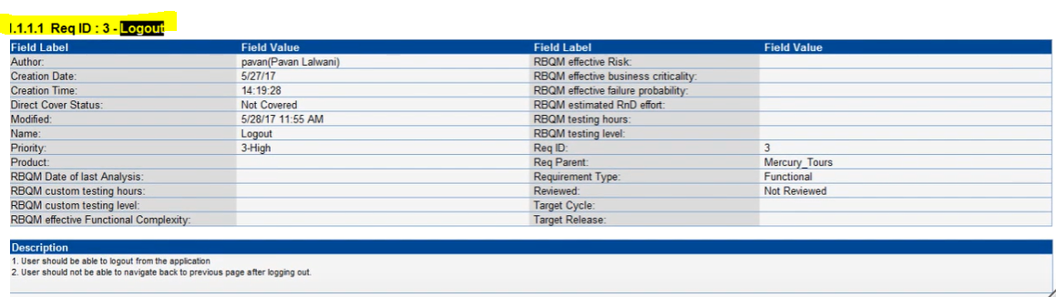

Then we have some available report options under analysis icon

* Report selected
* Report selected with children
* Requirements with Coverage tests
* Requirements with Coverage tests and steps
* Requirements with Linked defects
* Requirements with Traceability
* Standard Requirement Report
* Tabular Report

Tabular Report

